**Locating Solar Arrays Using ML Classification**

**Erich Brandstetter**

Denison University

Seminar in Data Analytics

**Abstract**

Renewable energy is a concept that is growing both in perception and utilization. This makes future placement a key concern. This project works to classify solar arrays from satellite images using two machine learning algorithms, Convolutional Neural Networks and Deep Belief Networks. This works to compare how the models run on satellite imagery problems, as well as to compare the most efficient data type between a multi-class set and a binary set. Through this, the models were able to achieve accuracies of up to 66%. While these models do not work with the future placement of solar arrays themselves, this provides the basis and setup for such a project, as it works to identify arrays, which can then be used alongside social and demographic data to gain a better understanding. The data was obtained from the USGS National Agricultural Imagery Program(NAIP) database.

1. **Introduction**

Technology is transforming the way that we see and interpret the world. It allows us to communicate in previously unheard of ways, travel across the globe quicker than ever and spend our leisure time in new levels of comfort. The unspoken aspect of this technological boom is the inherent costs associated; as we add more and more tech into our society, the demand and costs for the energy to keep it running increases rapidly. This calls for growth in the energy sector in order to meet this demand, and due to diminishing fossil fuels and as well as movement towards cleaner sources of renewable energy, this makes expanding the solar grid a viable solution to this problem.

The purpose of this project is to identify solar arrays from tiles of satellite images, sampled within the United States, using several machine learning algorithms. The first goal of this is to able to accurately predict which satellite images fed from an uncategorized test set of data contain solar images, based on the training of our models using previously classified images. Accomplishing this will help to set up future analytical projects, such as locating potential locations for future solar array placement. While this is not included within the scope of the current project, the purpose for this analysis is to move into this further stage.

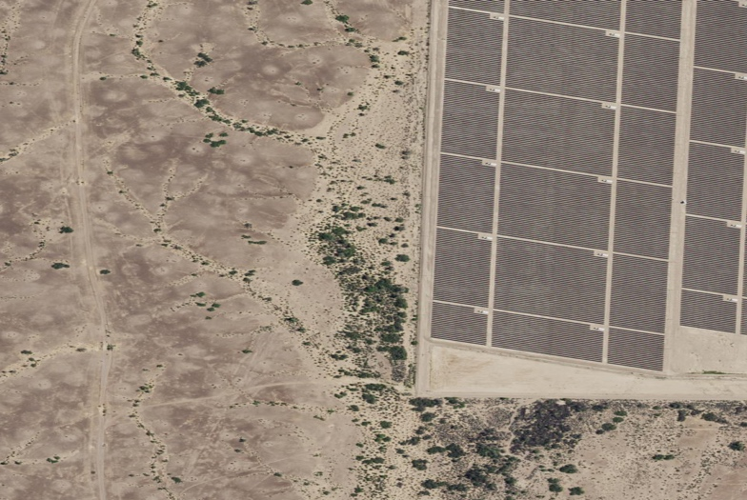

*A sample image of a desert solar array, highlighted in red*

The second goal of this project is to measure the accuracies of our two ML algorithms being used. For this, the purpose is to compare these accuracies in order to decide which model is more effective on image analysis of this scale. Previous research has identified the two models primarily being used, Convolutional Neural Networks and Deep Belief Networks, as being particularly effective in this kind of analysis. This project provides an opportunity to further explore the use of these processes in order to make a decision for future modeling purposes. Identifying which of these is more effective at satellite imagery analysis, which is still a somewhat unexplored field at this point, allows for future modeling decisions on other satellite imagery classification projects, which are abundant.

Solar energy represents a field which needs to be further analyzed in order to properly grow in ways which will benefit the population. In the next few years, as this industry continues to grow, it will become more and more crucial to optimize the placement of these. Using ML algorithms to identify arrays, this project takes the first step down this path towards optimization of placement, and allows for further development in satellite imagery analysis.

1. **Ethical Statement**

This project is being created as a class assignment at Denison University. The data being used is open-source and available for download. The data itself does not convey any information about any individuals, nor is the aim of the project to extract any individual information. The purpose of this project is to identify solar arrays from satellite imagery, and any use of this, or the identifications from this project, for any purpose other than this is unintended and are not condoned by the author.

1. **Literature Review**

While the purpose of this research is to classify solar arrays, previous studies have highlighted why this is a pertinent field for further exploration. Solar energy has been shown to be an effective way to produce energy, making up 7% of the energy produced in the US currently, and is expected to make up 36% of all energy production in the United States by the year 2050, according to the Center for Climate Solutions. As of 2007, studies observed roughly $10 Billion of solar energy produced worldwide, with a growth rate of 30% per year (Lewis 2007), equating out to roughly $46B today. As demand increases, economic theory tells us that price will also increase as a result, meaning this monetary amount has the potential to further inflate. Because of this, the placement of new larger scale solar projects will potentially become more prevalent. Solar farms typically take up 5 to 13 acre land plots (Arnette & Zobel 2011), and cost on average $4B (Sovacool et. al. 2014). On top of this, the energy from sunlight coming to the Earth in one hour exceeds the amount of energy used by all of human society in the course of a year (Lewis 2007). These factors all seem to lead into a niche of potential growth.

Solar cells themselves are formally known as Photovoltaic cells, meaning “light electricity”. These arrays work using what is called a “semiconductor”, which is an element used to absorb some of the light shining on it. The most common semiconductor used is Silicon. When the energy from the light is absorbed, this knocks some of the electrons from the Silicon, which allows it to travel freely as electricity. On average, on a sunny day with consistent light exposure, the sun will give off 1kW of energy per square meter of Earth’s surface (Toothman and Aldous 2000), providing potential for solar farm expansion to produce ample amounts of electricity for nearby areas. As this technology continues to advance further, the amount of energy of this 1kW potential will continue to grow as well, meaning that the size of a potential solar farm could reasonably shrink to limit total land being used while still producing energy at comparable rates. The energy from sunlight coming to the Earth in one hour exceeds the amount of energy used by all of human society in the course of a year (Lewis 2007).

One key downside to solar farms compared to other forms of renewable energies is the sheer scale of land required to build. Using the average of 5 to 13 acres to build a solar farm, these can be incredibly land intensive. Research has explored whether this is the most efficient use of land, comparing the use of land towards solar energy and bioenergy crops, which can be grown amongst wind turbines, as an example. Other methods for renewable energy, such as wind, can have positive externalities on the surrounding areas, such as farm land, which may make them more productive in more agricultural regions, as opposed to solar farms, which would themselves take up a significant portion of potential farm land. Thus, it becomes important to find a balance, as solar alone could negatively affect the areas around it indirectly due to such factors.

Another current downside with solar energy is the scalability of the farms. Because the farms can only operate at maximum of 70% efficiency in capturing energy (Lewis 2007), producing on a larger scale is not cost-efficient in most cases. Further more, when producing energies on such a large scale, it is incredibly difficult to store said energy, and is even more so cost inefficient. This leads to the conclusion that until such technologies advance, the mass production of solar farms is not efficient from a capital standpoint. This being said, due to the aforementioned demand for energy, these technologies are catching up and becoming more efficient and cheaper, further driving the use of solar energy in the future.

Previous studies have worked to identify arrays in the United States using deep learning (Yu et. al. 2018), which works to provide a basis for one aspect of this project. This study also identifies socio-economic factors, such as population density and income inequality, and how they correlate to the locations of solar paneling. Specifically, we see that areas with high population density are more likely to have a noticeably larger number of arrays. Although these factors are often not helpful in predicting locations because they are more so measuring features of existing paneling, this could provide beneficial knowledge towards optimizing the placement of new. As other research has stressed, solar resources alone do not optimize placement, as other factors, such as proximity and regional demand also contribute. These previously identified features could thus be used in order to differentiate between potential sites.

Other research has used hierarchical models using similar socio-economic factors to identify potential new placement for solar arrays (Uyal 2013), as well as other optimization models towards this same goal (Arnette & Zobel 2012). This research seeks to attain similar results, but updated with improved analytical methods, which can more accurately identify niche locations.

Satellite imagery has improved in recent years, but because of a lack of labelled data sets, classification problems have been more difficult to solve. However, previous research has been able to identify solar arrays (Jiafan et. al. 2018) , especially within residential areas, and further use this identification to find other social factors of the areas with the highest occurrence rates of arrays, such as Gini Index, which can further be used for future identification for potential sites. Other Research has focused around optimizing placement for solar farms, but using older methodologies and focusing around Multi-Criteria Analysis (MCA) to make all decisions. This allows for a combination of updated methodology, such as making use of more modern machine learning algorithms, with a similar basis around MCA in order to find potential new farm locations.

Because of the lack of labelled data, it can be difficult to properly build models, as machine learning algorithms will need to be trained with previously classified imagery. This being said, unsupervised machine learning algorithms have found significant success with satellite image identification, with some, such as Deep Belief Networks reaching accuracies of up to 93% (Basu et. al. 2015). Other frameworks have identified Convolutional Neural Networks and Stacked Denoising Autoencoders as successful algorithms for satellite image classification (ibid). Supervised learning methods, such as random forests, are not useful methods due to performance issues on large scale data.

Placement for solar farms is not a simple task, as many factors beyond just the solar resources involved make many sites infeasible. By accurately locating potential sites, this can allow for more accurate multi-criteria evaluations towards the placement of new farms. This can also stand to affect policy decisions as the world quickly begins transitioning to green and renewable energy sources. The demand for power is on the rise, and stands to continue this rise for the foreseeable future, meaning now more than ever, it is imperative that this energy is coming from the right sources, or we as a society may stand to do irreparable damage to the very planet we seek to power.

1. **Methodology**

This aim of this project is to use machine learning algorithms to identify solar arrays from satellite imagery data. In order for this project to be successful, certain steps must be followed. First, the images to be used as data need to be gathered. Once this is done, these images will need to be manually classified, as they will not be in a pre-classified form. Once this is done, the structure of the images needs to be appended before they can then be transformed into data that can be fed into the neural network models created. The data will be divided into a set to train the models on as well as a set to test the accuracies of the models

**4.1 Data**

The data was gathered from the USGS National Agricultural Imagery Program (NAIP) Satellite. This is available open-source from the USGS EarthExplorer application. From here, it was necessary to properly identify solar arrays from this imagery to build up a strong enough sample size for the model be able to identify in the non-classified images. In order to locate these, the Descartes Labs interactive map was utilized alongside the EarthExplorer interface, a process consisting of scrolling across the countryside in order to locate arrays. Once these images were located, they could be downloaded, using the USGS Bulk Download application. One issue that was encountered at this point was the size of each image file, which averaged at about 500 MB apiece.



*Example 1: A full Sized NAIP Image of the “Solar Array” class*

The images were reduced down to a size of roughly 25 MB, and then sliced into 40 smaller images apiece. The size of the images necessitated this division because Solar Arrays would be too small and inconsiderable of a feature in the larger images, while smaller images allow the arrays to be a more prominent feature. This also worked to increase the size of the dataset itself by a scale of 40.

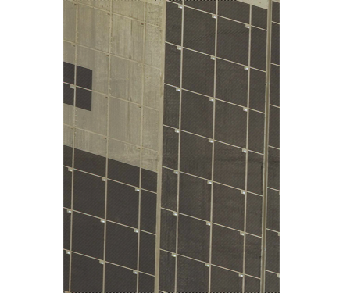

*Example 2: A sliced Image showing a solar array*

At this point, the data was reduced in dimensionality, to a dimensionality of 32 pixels by 32 pixels by 3 color wavelengths. This was done because the pixel dimensions of the images were too large to effectively read in or utilize as data, as well as because studies have shown neural net models to have more success working with low resolution images when working with image classification(cite). Specifically, the size of 32x32 was chosen because Convolutional Neural Networks have been shown to work better on images with pixel dimensions that are exponents of 2(cite). Each image was read in twice, once where it had been flipped vertically and once in its original form. This was done in order to double the size of the working data set. This dataset consists of 3528 images, represented by arrays of 3072 (32x32x3) pixels.

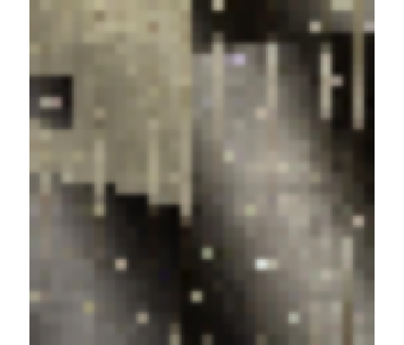

*Example 3: A reduced-pixel image of a solar array*

Once this was done, the final step before analysis could begin was the manual classification of images. This was necessitated by the lack of existing pre-classified satellite image datasets. Previous studies of a similar nature recommended outsourcing these processes, as they are incredibly time intensive, particularly for an individual process. Because the data was in fact just the same images repeated twice, this cut the time necessary for classification in half.

**4.2 Algorithms**

The methods which are used in this project focus around two key ML algorithms. These algorithms are Convolutional Neural Networks (CNN) and Deep Belief Networks (DBN). These are both classes of traditional Deep Neural Nets, and employ them in some form during the decision making process. Neural nets consist of both visible layer manipulations and hidden layer manipulations. Because of this, neural nets are considered to be “Black Box” algorithms, as it is uncertain the exact operations occurring once the data has passed through the visible layers. Both CNNs and DBNs have been identified as being effective when working with image classification.

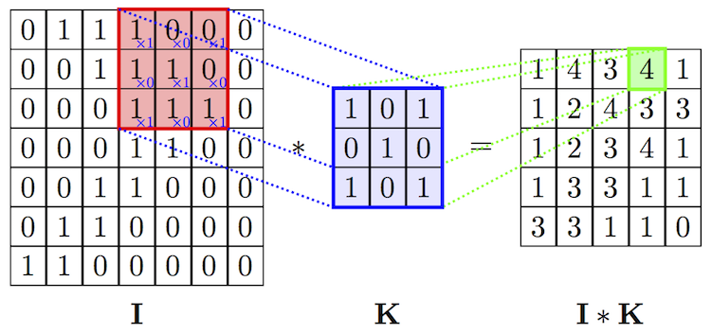

*Example 4: Convolutional Filter*

The first model to be worked with was the CNN. A CNN first works by employing convolutional layers, which act by using a colored filter along each of the three color wavelengths. This filter, which mathematically be seen as a 3x3 matrix, slides across the image, and using matrix multiplication between itself and a subset matrix from the original image, acts as a feature detector. Each of the three color wavelengths detects and creates a different feature map for the image. By changing the values within the filter before convolution, it allows for the operation of that filter to change, such as working as an edge detector or as a blurrer. The model employed in this project used 32 filters in each of its first two convolutional layers, the values of which are learned by the model as it is fed a set of training data. The convolutional layers within this model make use of Rectified Linear Units (ReLU) as an activation function. ReLU works by transforming all negative valued pixels to 0 value pixels. This method has been found to run better than tangential and sigmoid activation functions in most occurrences (Ujjwalkarn 2017).

Once the images are input through the initial two convolutional layers, they are then sent the initial pooling stage. The pooling stage is done in order to reduce the dimensionality of the images, but retaining key information. This works by taking the max value out of, in this case, 2x2 pixel strides across the input feature map. This is ran across all three layers of feature maps. From here, the data has been reduced in both parameter and pixel size, further reducing the number of computations needing to be run.

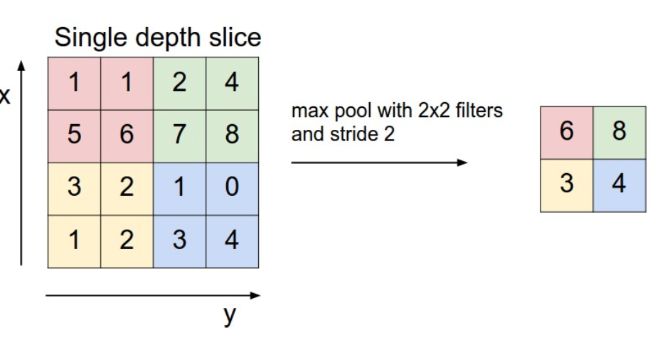

*Example 2: Pooling Layer*

Next, once the data has been fed through the pooling layer, it is first sent through a dropout layer, which works to reduce model overfit, before it is again sent through more convolutional layers, this time containing 64 filters apiece. After this, it is sent through another set of pooling and dropout layers, before being sent through the final flattening layer. This layer works to reduce the 3 layers of input array down into a single layer matrix.

At this point, the data is run through a “Fully Connected Layer”[1], which is a traditional neural net using a softmax activation function. The softmax function works by reducing a vector of values down into a vector of values between 0 and 1, with the vector summing in total to 1. This stage in the CNN is the decision making stage, where the model will undergo classifications.

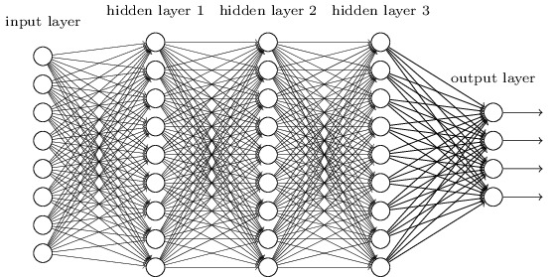

*Example 5: Fully Connected Layer*

The fully connected layer used in this model makes use of 256 connected neurons. The results of this are sent into an output layer, which uses Categorical Crossentropy or Binary Crossentropy as its loss function, depending upon the whether the data being used is multi-class or binary class, in order to return metrics of accuracy for model comparison. Both the binary and multi-class CNNs were ran over 250 epochs for training, with a decay value of 1e-06. Overall, this model made use of 4 convolutional layers, The model was coded in R, using the Tensorflow engine and the Keras package.

Once the CNN was fully employed, the next step was to create the Deep Belief Network. A Deep Belief Network is actually a structure created when stacking multiple Restricted Boltzmann Machines (RBM) on top of one another. RBMs are themselves another graphical machine learning model, that when trained create a hierarchical representation of the data. In Example 4, we see the structure of the DBN, where $h_{i}$ are the hidden layers building the inner network and *x* is the output layer of the network. Within this, $h_{i}$ are the RBMs, making the set of hidden layers the stack of RBMs within the model. DBNs are again “Black Box” algorithms, so the exact operations occurring within are unknown.

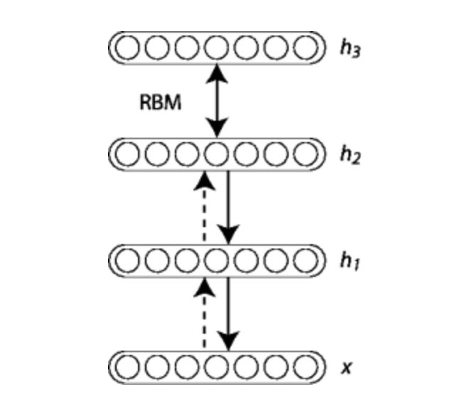

*Example 6: Stacked RBMs in a Deep Belief Machine*

The Restricted Boltzmann machines that make up the hidden layers of the DBN are preforming stochastic gradient descent upon the log-likelihood from the data it is trained on. This essentially reduces the computational requirements on the data by smoothing over it by minimizing an optimization function, usually a summation. In this case, the optimization function used was $\frac{1}{N}\sum_{x_{i}∈D}{\log{p(x_{i})}}$, where *N* is the number of observations in dataset *D*, $x_{i}$ is a variable in dataset *D*, and *p(x)* is the likelihood estimate. This works especially for operations such as edge detection, which is a key method used on image classifications. By identifying where the data is changing, this allows the algorithm to better extract information about the object that is being identified.

The model in use used a stack of three RBMs and trained over 250 epochs and a batch size of 32, the same parameters being utilized by the CNN above. For both of these models, the metrics for comparison being used are general classification accuracy, accuracy over the solar array class on the multi-class nets, as well as general metrics of sensitivity and specificity on the binary set.

1. **Results**

The dataset we have consists of 1764 images which have been reflected to double sample. This allowed us to use a training set of 3100 images, as well as a test set of 428 images. The training set contains 694 images classified as solar arrays compared to 2406 images classified as six other land types: desert, mountain, lake, urban, fields and farmland. Within the test set, there were 39 observed solar arrays, against 389 otherwise classified images.

**5.1 CNN**

The first model tested was the Convolutional Neural Network. The was tested twice, once on a fully classified data set, and once on a dataset with binary solar array/non-solar array classifications. These were run in this fashion in order to compare the effectiveness of the model based on different classifications types. The first of these models to be tested was the full, multi-class model.

The multi-class CNN took roughly 30 minutes to train on 250 epochs, and validated on a 12% subset of the training data. Training accuracy converged out at .98, while training loss converged at .028. Overall, the model responded well to the training set, despite a class imbalance between the 3 more observed image classes and the 4 lesser observed classes.

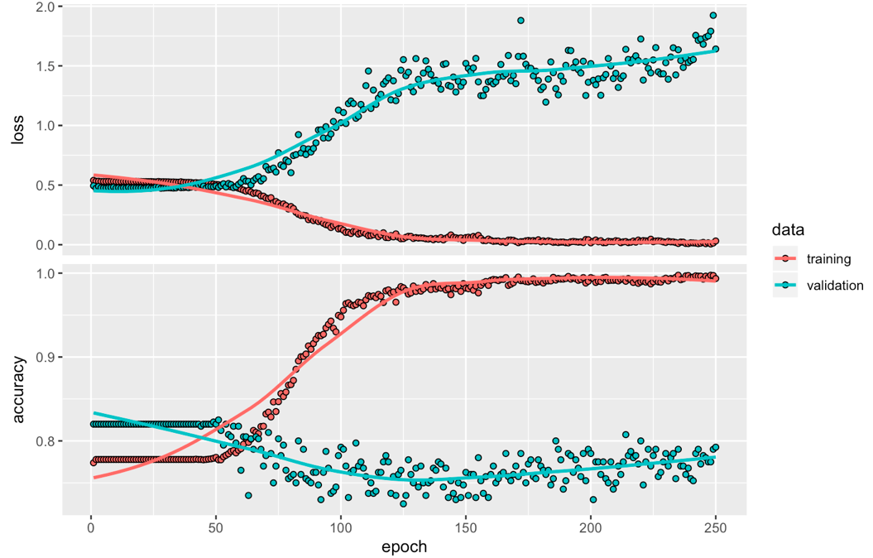

*Figure 1: Training and Validation Loss and Accuracy on Multi-Class model*

**Actual**

|  |  |  |  |  |  |  |  |
| --- | --- | --- | --- | --- | --- | --- | --- |
| **Predicted** | Desert | Farmland | Fields | Lake | Mountain | Array | Urban |
| Desert | 134 | 0 | 44 | 2 | 1 | 26 | 42 |
| Farmland | 0 | 6 | 1 | 0 | 0 | 1 | 1 |
| Fields | 1 | 0 | 17 | 2 | 0 | 0 | 1 |
| Lake | 0 | 0 | 0 | 0 | 0 | 0 | 0 |
| Mountain | 0 | 0 | 0 | 0 | 0 | 0 | 1 |
| Array | 11 | 1 | 4 | 1 | 1 | 11 | 4 |
| Urban | 2 | 0 | 1 | 0 | 0 | 2 | 10 |

*Figure 2: Multi-Class CNN Test Classification Table*

Figure 2 shows the result classifications of the multi-class CNN on the test set of 428 images. This returned a general accuracy metric of .416. It successfully classified 11 solar arrays, out of the total of 40, or 27.5%. It also classified 11 desert tiles as solar arrays, an equivalent amount, albeit from a larger sample of images. Of the total images classified as solar arrays, 2 out of every 3 was a false positive.

Moving on to the binary classification model, this model trained on 250 epochs in 20 minutes, slightly shorter than the multi-class model. The training accuracy converged at .96, and the training loss at .34. This model responded much worse than the previous to the training set initially due to the much larger class imbalance coming from combining the non-array classes, although the final accuracy converged at a much higher point.

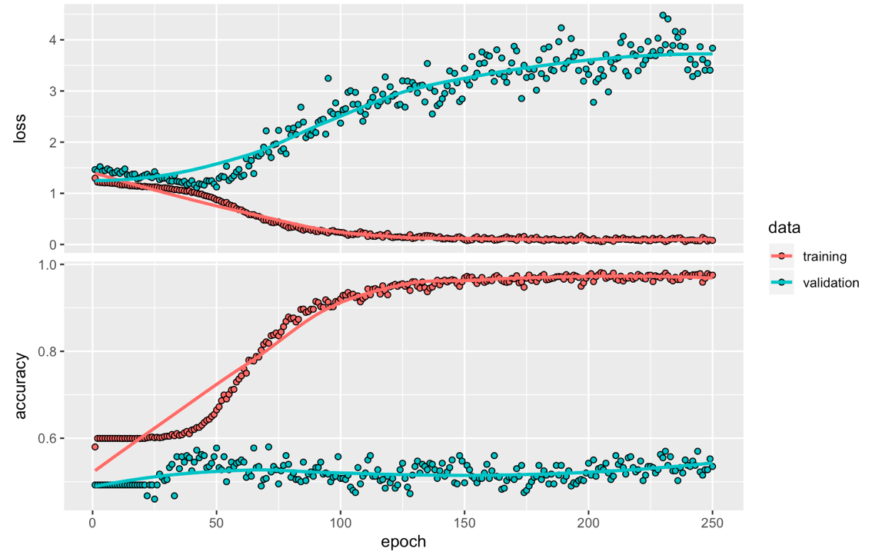

*Figure 3: Training and Validation Loss and Accuracy on binary-class model*

**Actual**

|  |  |  |
| --- | --- | --- |
| **Predicted** | Solar Array | Non-Array |
| Solar Array | 6 | 11 |
| Non-Array | 34 | 277 |

*Figure 4: Binary Class CNN Test Classification Table*

Figure 4 shows the result classifications from the binary class CNN model. This correctly classified 283/428 images, returning a test accuracy of .661. The sensitivity of this model, which represents the true positive classifications divided by the total number of array classifications, was .353. This tells us that 35.3% of the images classified as arrays are in fact solar arrays. The model correctly 6/40 solar arrays, meaning it correctly categorized 15% of arrays.

Overall, the results of this model seemed to be skewed by model overfit to the Desert classification. This can be seen due to the imbalance between classes, as well as the model’s tendency to falsely classify other classes as the desert class. This continues into the binary set, as our model displays a similar tendency towards classifying to the non-solar array class.

**5.2 DBN**

After the CNNs ran, the project moved onto the Deep Belief Networks. The DBN gave a mixed bag of results, as it ran on the multi-class data set, but was unable to run on the binary classifications. This means the potential comparisons for results is lesser, although the multi-class can still be compared.

**Actual**

|  |  |  |  |  |  |  |  |
| --- | --- | --- | --- | --- | --- | --- | --- |
| **Predicted** | Desert | Farmland | Fields | Lake | Mountain | Array | Urban |
| Desert | 131 | 1 | 46 | 2 | 2 | 29 | 45 |
| Farmland | 0 | 6 | 2 | 0 | 0 | 0 | 0 |
| Fields | 1 | 0 | 17 | 0 | 0 | 0 | 0 |
| Lake | 0 | 0 | 0 | 0 | 0 | 0 | 0 |
| Mountain | 0 | 0 | 0 | 0 | 0 | 2 | 0 |
| Array | 13 | 0 | 2 | 2 | 0 | 9 | 6 |
| Urban | 3 | 0 | 0 | 0 | 0 | 0 | 8 |

*Figure 5: Multi-Class DBN Test Classification Table*

Figure 5 shows the result classifications from the DBN on the test set. The DBN returned a general accuracy metric of .399. This classified 9 out of 40 total solar arrays correctly, 22.5%. This model misclassified 23 non-array images as arrays, giving the model sensitivity for solar arrays at 28.125%. Overall, this seemed to have performed worse than both of the solar array models.

The binary DBN model would not correctly run, and thus did not yield any results. This may be a result of the package being used, or some other encoded error, however, after hours spent trying to debug this error, this has been chosen to be excluded from further analysis.

1. **Discussion**

Out of the three models that were able to give results, the Convolutional Neural Networks seemed to have the most success at classifying solar arrays. Comparing the model accuracies of the two, the binary model performs better, with an accuracy of .661 compared to .416. This is somewhat deceptive, as the majority of the correctly classified images for both fall into a non-solar array class. In this sense, the multi-class model may in fact be better, as it still had more success correctly classifying the solar arrays themselves, as it categorized 27.5% opposed to 15% for the binary model.

Between the multi-class models, there is little question that the CNN performed better on the test metrics. The accuracy of the CNN is slightly larger, at .416 compared to .399, and the CNN categorized 27.5% of solar arrays , compared to the 22.5% by the DBN. On top of this, the DBN was much more computationally heavy, and had a longer training time than that of the CNN.

Because the DBN on the binary set would not run correctly, we are unable to compare the results between the binary CNN and DBNs. However, based on the results of both the CNN and DBN on the multi-class set being better than those of the binary CNN, it is a fair assumption to say that the multi-class set is a better method for classification.

This study has several limitations to it, primarily with the data. None of the models performed incredibly, with the reason most likely being that the size of the training set is limited. Future studies would do well to increase the size of the data set being used, as well as to accommodate for the class imbalance in both the training and test sets, specifically the difference between observed solar arrays and desert tiles. While having a larger number of classes may give the model more information as well, however eliminating classes with little-to-no observations may give the model more predictive ability. Further more, using a wider array of algorithms may be an interesting continuation of this study, as other machine learning algorithms, such as the Extreme Learning Machine (XLM), as documented by Guang-bin Huang, have shown to have made advances in the field of imagery classification.

Overall, CNNs seem to be the model of choice for satellite image classification problems. While none of the models performed exceptionally, the CNNs out-performed the DBN models at classifying solar arrays. This paired with less of a run time, as well as a simpler research and implementation time make this model much more efficient for the problem at hand. Thus, the recommendation of this study for future work on satellite imagery classification is to use the Convolutional Neural Network.

1. **References**

Arnette, Andrew, and Christopher W. Zobel. “An Optimization Model for Regional Renewable Energy Development.” *Renewable and Sustainable Energy Reviews*, vol. 16, no. 7, 2012, pp. 4606–4615., doi:10.1016/j.rser.2012.04.014.

Basu, Saikat, et al. “DeepSat.” *Proceedings of the 23rd SIGSPATIAL International Conference on Advances in Geographic Information Systems - GIS '15*, 3 Nov. 2015, doi:10.1145/2820783.2820816.

Calvert, K., and W. Mabee. “More Solar Farms or More Bioenergy Crops? Mapping and Assessing Potential Land-Use Conflicts among Renewable Energy Technologies in Eastern Ontario, Canada.” *Applied Geography*, vol. 56, 2015, pp. 209–221., doi:10.1016/j.apgeog.2014.11.028.

*Convnet-Notebook*, 2016, perso.mines-paristech.fr/fabien.moutarde/ES_MachineLearning/TP_convNets/convnet-notebook.html.

“Deep Belief Networks¶.” *Deep Belief Networks - DeepLearning 0.1 Documentation*, deeplearning.net/tutorial/DBN.html.

Jean, N., et al. “Combining Satellite Imagery and Machine Learning to Predict Poverty.” *Science*, vol. 353, no. 6301, 2016, pp. 790–794., doi:10.1126/science.aaf7894.

Lewis, N. S. “Toward Cost-Effective Solar Energy Use.” *Science*, vol. 315, no. 5813, 2007, pp. 798–801., doi:10.1126/science.1137014.

Nielsen, Michael A. “Neural Networks and Deep Learning.” *Neural Networks and Deep Learning*, Determination Press, 1 Jan. 1970, neuralnetworksanddeeplearning.com/chap6.html.

Oquab, Maxime, et al. “Learning and Transferring Mid-Level Image Representations Using Convolutional Neural Networks.” *2014 IEEE Conference on Computer Vision and Pattern Recognition*, 2014, doi:10.1109/cvpr.2014.222.

“Package 'Pixmap'.” *Cran-R Project*, 15 Feb. 2015, cran.r-project.org/web/packages/pixmap/pixmap.pdf.

“Renewable Energy.” *Center for Climate and Energy Solutions*, 1 Nov. 2017, www.c2es.org/content/renewable-energy/.

Timilsina, Govinda, et al. “A Review of Solar Energy Markets, Economics and Policies.” *Solar Energy*, 2014, pp. 167–215., doi:10.1201/b17731-12.

Toothman, Jessika, and Scott Aldous. *How Solar Cells Work*. *How Solar Cells Work*, How Stuff Works, 2000.

Ujjwalkarn. “An Intuitive Explanation of Convolutional Neural Networks.” *Ujjwalkarn*, 29 May 2017, ujjwalkarn.me/2016/08/11/intuitive-explanation-convnets/.

Uyan, Mevlut. “GIS-Based Solar Farms Site Selection Using Analytic Hierarchy Process (AHP) in Karapinar Region, Konya/Turkey.” *Renewable and Sustainable Energy Reviews*, vol. 28, 2013, pp. 11–17., doi:10.1016/j.rser.2013.07.042.

Vincent, Pascal, et al. “Stacked Denoising Autoencoders: Learning Useful Representations in a Deep Network with a Local Denoising Criterion.” *Journal of Machine Learning Research*, 10 Dec. 2010.

Yu, Jiafan, et al. “DeepSolar: A Machine Learning Framework to Efficiently Construct a Solar Deployment Database in the United States.” *Joule*, vol. 2, no. 12, 2018, pp. 2605–2617., doi:10.1016/j.joule.2018.11.021.

1. Term refers to when every neuron in a given layer have a connection to every neuron in the following layer.